# ABSTRACT

Choosing the right hospital is a critical decision that significantly impacts patient outcomes and satisfaction. However, traditional hospital review systems, which often rely on simple star ratings, fail to capture the nuanced and multifaceted nature of patient experiences. These aggregated scores provide limited actionable insights, as they obscure the reasons behind the ratings and overlook the specific aspects that patients prioritize, such as staff behavior, cleanliness, facilities, wait times, and cost transparency. This lack of granularity makes it challenging for patients to make informed decisions tailored to their needs and for hospitals to identify and address areas of improvement effectively. To address these shortcomings, our study introduces a comprehensive framework for aspect-based sentiment analysis, which decomposes patient reviews into distinct categories for detailed evaluation. By focusing on multiple aspects rather than a single aggregated score, the system empowers users to prioritize and sort hospitals based on the criteria most important to them. For instance, a user can identify hospitals with the cleanest facilities, the most efficient staff, or the shortest wait times, enabling highly personalized and informed decision-making. To ensure robust sentiment analysis, we employ and compare three distinct sentiment models— TextBlob, VADER, and BERT—each with its unique strengths. TextBlob provides a lexicon-based analysis that is straightforward and interpretable but may struggle with nuanced language. VADER, optimized for social media and informal text, effectively captures sentiment intensity and handles complex linguistic structures like negations. BERT, a transformer-based model, excels in understanding deep contextual relationships within text, making it particularly adept at deciphering subtle sentiments in detailed hospital reviews. By evaluating these models side-by-side, our study examines their performance and identifies correlations and discrepancies, thereby ensuring the reliability of sentiment assessments across various aspects. Our approach benefits users and healthcare institutions alike. Patients are equipped with an intuitive system that highlights the strengths and weaknesses of hospitals in key areas, simplifying the decision making process. Hospitals, on the other hand, gain access to actionable insights that enable them to target specific areas for improvement, such as reducing wait times or enhancing staff interactions. To enhance accessibility and engagement, we visualize the findings through interactive dashboards, which present sentiment distributions, aspect-specific comparisons, and hospital- level insights using tools like Matplotlib and Seaborn. This study bridges the gap between oversimplified review systems and the complex realities of patient care by offering a detailed, aspect-driven analysis of hospital reviews. By empowering users to make better-informed choices and providing hospitals with the data-driven insights needed to improve services, our framework represents a significant step forward in optimizing the healthcare decision making process and improving patient satisfaction.

|  |  |
| --- | --- |
| **DESCRIPTION** | **PAGE NUMBER** |
| BONAFIDE CERTIFICATE | ii |
| CERTIFICATE OF APPROVAL | iii |
| DECLARATION | iv |
| ACKNOWLEDGEMENTS | v |
| ABSTRACT | vi |
| LIST OF FIGURES | viii |
| LIST OF TABLES | ix |
| 1. INTRODUCTION | 1-3 |
| 1.1 Shortcomings of Star-Based Reviews | 1 |
| 1.2 Benefits of Aspect-Based Sentiment Analysis | 1-2 |
| 1.3 Role of Multiple Sentiment Models | 2 |
| 1.4 Enhancing User Experience | 2-3 |
| 1.5 Contribution of This Study | 3 |
| 2. LITERATURE STUDY | 4-5 |
| 3. METHODOLOGY | 6-9 |
| 3.1 Dataset Preparation | 6 |
| 3.2 Aspect Identification, Sentiment Analysis Techniques, Data Annotation and Processing, | 7 |
| Metric Computation  3.3 Visualization, Dashboard Implementation, Error Handling | 8 |
| and Logging  3.4 Application Workflow, Evaluation | 9 |
| 4. RESULT AND DISCUSSION | 10-13 |
| 4.1 Overall Sentiment Distribution | 10 |
| 4.2 Aspect-Specific Analysis | 10-11 |
| 4.3 Hospital-Specific Sentiment Analysis | 11-12 |

|  |  |
| --- | --- |
| 4.4 Discussion | 13 |
| 5. CONCLUSION | 14-15 |
| 6. REFERENCES | 16 |

|  |  |  |
| --- | --- | --- |
| **FIGURE** | **TITLE** | **PAGE NUMBER** |
| 1. | Block Diagram | 09 |
| 2. | Sentiments across all aspects | 10 |
| 3. | Average scores by hospital for a selected aspect | 11 |
| 4. | Focused visualizations for individual hospitals | 12 |

|  |  |  |
| --- | --- | --- |
| **TABLE** | **TITLE** | **PAGE NUMBER** |
| 1. | Dataset Sample | 06-07 |
| 2. | Scores for hospitals based on aspects | 12-13 |

# Introduction

In today’s digitally driven world, online reviews play a pivotal role in shaping consumer decisions, particularly in critical sectors such as healthcare. Hospitals, being a cornerstone of public health, rely on patient feedback to refine their services, improve quality, and build trust among communities. However, most review systems for hospitals and healthcare services remain overly simplistic, often relying on aggregated star ratings. While convenient, these star- based reviews lack the depth and nuance

necessary for meaningful insights, especially in a domain where experiences are highly subjective and multifaceted.

**Shortcomings of Star-Based Reviews**

Star-based rating systems offer a quick snapshot of user sentiment but fall short in capturing the complexity of patient experiences for several reasons:

1. **Ambiguity of Ratings:** A single numerical value often cannot encapsulate the broad spectrum of a patient’s experience. For instance, a hospital may have excellent staff and modern facilities but may still receive lower ratings due to factors like high costs or long waiting times. Star ratings fail to provide clarity on why a particular rating was given.
2. **Lack of Context:** Star ratings lack explanatory detail. Patients’ needs vary widely—while one individual may prioritize cleanliness and staff behavior, another may focus on affordability or the availability of specialized medical services. An aggregated score obscures this context, making it difficult for users to discern whether a hospital meets their specific requirements.
3. **Subjectivity:** The interpretation of a star rating is highly subjective and influenced by personal biases. What constitutes a “5-star” experience for one individual may only warrant a “3-star” for another, leading to inconsistency in the rating system.
4. **Limited Actionability:** From a hospital's perspective, star ratings provide minimal actionable insights. A poor rating does not pinpoint whether the issue lies with staff behavior, facilities, or operational inefficiencies, limiting the ability to target improvements effectively.

## Benefits of Aspect-Based Sentiment Analysis

Aspect-based sentiment analysis addresses these shortcomings by breaking down reviews into specific categories, or “aspects,” such as staff behavior, cleanliness, facilities, wait time, and cost. This granular approach has several advantages:

1. **Nuanced Insights:** By categorizing feedback, aspect-based sentiment analysis provides a detailed understanding of what patients appreciate or dislike. For example, a hospital may score poorly on wait time but excel in facilities, allowing prospective patients to weigh the trade-offs based on their priorities.
2. **Customizability for Users:** Users have diverse needs and expectations when choosing a hospital. Our system allows users to sort hospitals based on the aspects most important to them, such as selecting the cleanest facility or one with the shortest waiting times. This empowers patients to make informed decisions tailored to their specific requirements.
3. **Actionable Insights for Hospitals:** Aspect-based sentiment analysis enables hospitals to identify and address specific areas of concern. For instance, a hospital receiving negative feedback on cost transparency can work towards better communication of pricing policies, while maintaining strengths in other areas like staff behavior.
4. **Contextual Depth:** Unlike star ratings, aspect-based analysis captures the underlying reasons behind user sentiments. This makes it easier to identify systemic issues and improve patient satisfaction holistically

## Role of Multiple Sentiment Models

To ensure the robustness and reliability of sentiment analysis, our study leverages three different sentiment analysis models—TextBlob, VADER, and BERT—each offering unique advantages:

## TextBlob:

A lexicon-based model that provides a straightforward analysis of polarity and subjectivity. It is lightweight and interpretable but may struggle with nuanced or contextual language.

## VADER:

Designed for social media sentiment analysis, VADER excels at understanding the intensity of sentiment in short and informal texts. Its ability to handle negations and emojis makes it particularly useful for hospital reviews that often contain casual language.

## BERT:

A state-of-the-art transformer-based model that delivers deep contextual understanding of text. BERT captures subtle sentiments and nuances, making it ideal for complex and detailed reviews. However, its computational complexity necessitates robust resources for deployment.

By comparing these three models, we aim to identify correlations and discrepancies in their outputs. This comparison helps validate the reliability of our findings and provides insights into the strengths and weaknesses of each model in the context of aspect-based sentiment analysis.

## Enhancing User Experience

Our system goes beyond traditional reviews by offering users the ability to:

1. **Sort Hospitals Based on Specific Aspects**: Users can prioritize aspects that matter most to them, such as finding a hospital with the most compassionate staff or the shortest wait times.
2. **Gain Detailed Comparisons**: By presenting sentiment distributions across multiple aspects, users can easily compare hospitals and make well-informed decisions.
3. **Access Visual Insights**: Interactive visualizations provide a clear and engaging way to explore sentiment data, ensuring accessibility for all users.

## Contribution of This Study

This study introduces a novel approach to hospital reviews by combining the strengths of aspect-based sentiment analysis and multiple sentiment models. Our comprehensive framework addresses the limitations of traditional rating systems while providing hospitals with actionable insights to improve patient care. By focusing on the aspects that matter most to users, we bridge the gap between raw patient feedback and meaningful decision-making tools.

The analysis not only enables users to find hospitals aligned with their needs but also establishes a data-driven foundation for healthcare institutions to enhance their services, ultimately contributing to improved patient satisfaction and healthcare outcomes.

# LITERATURE SURVEY

Aspect-Based Sentiment Analysis (ABSA) has become an essential research area in Natural Language Processing (NLP) due to the rise of user-generated content. ABSA identifies specific aspects within text and classifies sentiment for each aspect, proving particularly useful in industries like healthcare where patient feedback is crucial for improving services.

## Early Approaches

Early ABSA methods relied on lexicon-based approaches, such as Hu and Liu's (2004) model, which used sentiment lexicons to identify aspects. These methods, while effective for broad sentiments, struggled with contextual understanding, especially in complex domains like healthcare. Doing-Harris et al. (2017) applied such methods to analyze patient feedback, but they faced limitations in handling nuanced expressions and sentiment shifts.

## Deep Learning Advancements

The advent of deep learning marked a shift in ABSA techniques. Models like Long Short-Term Memory (LSTM) networks captured long-range text dependencies effectively. Tang et al. (2016) introduced an LSTM-based model for joint aspect extraction and sentiment classification, while Wang et al. (2016) improved accuracy with attention mechanisms.

Transformer-based models like BERT (Devlin et al., 2019) revolutionized ABSA by enabling better context-dependent analysis. Fine-tuned for ABSA tasks, models such as BERT and RoBERTa (Liu et al., 2019) significantly outperformed earlier methods, especially in handling complex language like healthcare reviews.

## Applications in Healthcare

Researchers have utilized deep learning for healthcare-specific ABSA. Gao et al. (2019) and Xu et al. (2019) demonstrated the efficacy of BERT in analyzing drug reviews and hospital feedback, outperforming traditional models. Ranard et al. (2016) highlighted the value of mining hospital reviews, paving the way for focused ABSA applications.

## Our Contribution

Building on these advancements, our research applies ABSA to hospital reviews using Pandas, NLTK, and Scikit-learn, focusing on aspects like service, cleanliness, food, facilities, and staff behavior. We aggregate aspect-level sentiment scores into an overall hospital rating and validate this against existing star ratings.

Key contributions include:

1. **Domain-Specific Focus:** Applying machine learning to healthcare reviews.
2. **Score Aggregation:** Aggregating aspect-level scores for nuanced hospital evaluations.
3. **End-to-End Pipeline:** Developing a comprehensive system from web scraping to validation.
4. **Future Exploration:** Considering hybrid and deep learning models for further accuracy improvements.

This work aims to improve sentiment analysis and provide actionable insights for healthcare administrators to enhance service quality and patient care.

# METHODOLOGY

This study employs a systematic approach to aspect-based sentiment analysis (ABSA) of hospital reviews to evaluate various aspects of hospital services. The analysis integrates multiple sentiment analysis techniques, leveraging advanced natural language processing (NLP) methods and visualization tools. Below, the methodology is detailed comprehensively.

## Dataset Preparation

The analysis begins with data ingestion and preprocessing:

* + A CSV file containing hospital reviews is uploaded. The dataset is expected to include columns such as *title*, *text*, and *totalScore*.
  + Reviews with missing or incomplete data are excluded to ensure quality analysis.
  + The dataset is cleaned and tokenized using the Natural Language Toolkit (NLTK).

|  |  |  |
| --- | --- | --- |
| **Total Score** | **Text** | **Title** |
| 4.6 | Very bad service don't go their treatment | Sunshine Hospital |
| 4.6 | Biswajit Mishra | Sunshine Hospital |
| 4.6 | Don't go to this hospital. Extremely unprofessional staffs. Bad behavior with no sense of empathy for patients. Not transparent with patients. Some of the reports were not provided and the patient had to leave without any clear understanding of diagnosis or treatment.  It's a complete failure of hospital management (not sure if they have one). | Sunshine Hospital |
| 4.6 | Very Good behavior Doctors and staffâ¤ï¸ Giving Five stars for all the services started form Emergency ward through ICU to General  ward and finally time of Discharge â¤ï¸ | Sunshine Hospital |
| 4.6 | Room size very small in compare to price. A little bit improvement needed in room service part. | Sunshine Hospital |
| 4.6 | Excellent Hospital.Pleased with the service rendered by the esteemed doctors ,nursing staff and house keeping staff.  My best wishes to all. | Sunshine Hospital |
| 4.6 | All good | Sunshine Hospital |

|  |  |  |
| --- | --- | --- |
| 4.6 | All services are good | Sunshine Hospital |
| 4.6 | All services are very good | Sunshine Hospital |

**Table 1: Dataset Sample**

## Aspect Identification

Aspect extraction involves identifying predefined categories relevant to hospital reviews:

* + A custom **Aspect Dictionary** is utilized, containing keywords grouped into categories such as staff, cleanliness, wait_time, facilities, cost, and communication.
  + Text data is tokenized using NLTK, and keywords matching any aspect are extracted.
  + The aspect extraction function maps these keywords to their respective categories, allowing for structured analysis.

## Sentiment Analysis Techniques

Three sentiment analysis models are applied to each review:

* + **TextBlob**: This library analyzes the text's polarity, categorizing sentiment as Positive, Neutral, or Negative based on polarity thresholds.
  + **VADER (Valence Aware Dictionary and Sentiment Reasoner)**: It evaluates the sentiment using a lexicon-based approach with intensity scores.
  + **BERT**: A transformer-based sentiment model, fine-tuned for multilingual tasks, is employed for robust contextual sentiment classification.

## Data Annotation and Processing

The sentiment analysis results are annotated for each review:

* + Each review is processed to determine sentiment for all extracted aspects using the three sentiment models.
  + Results are collated in a structured format, with each row representing an aspect-review combination and including:
    - Hospital name.
    - Total score.
    - Aspect.
    - Sentiment ratings from TextBlob, VADER, and BERT.

## Metric Computation

To derive actionable insights, metrics are calculated at the hospital and aspect levels:

* + **Sentiment Distribution**: The proportion of Positive, Neutral, and Negative reviews for each aspect and hospital.
  + **Average Scores**: The mean of *totalScore* values for each aspect.
  + **Mention Counts**: The number of times each aspect is discussed in reviews.
  + Results are organized into a tabular format for comparison across hospitals.

## Visualization

Data visualization aids in interpreting results:

* + **Sentiment Distribution Plots**: Comparative bar charts for TextBlob, VADER, and BERT sentiments across all aspects.
  + **Aspect Comparisons**: Bar plots highlighting sentiment distribution, mention counts, and average scores by hospital for a selected aspect.
  + **Hospital-Specific Sentiment Analysis**: Focused visualizations for individual hospitals. These visualizations are created using Matplotlib and Seaborn and rendered interactively via Streamlit.

## Dashboard Implementation

An interactive dashboard is developed using Streamlit:

* + **Data Upload**: Users can upload datasets for analysis.
  + **Overall Metrics**: The dashboard provides a summary of sentiment distributions and average hospital ratings.
  + **Aspect and Hospital Filters**: Users can drill down into specific aspects or hospitals to view detailed sentiment trends.
  + **Progress Tracking**: A progress bar indicates the analysis completion status.

## Error Handling and Logging

Robust error handling ensures the application's reliability:

* + Errors during data loading or processing are logged using Python’s logging library.
  + Users are notified of any issues via the dashboard interface, ensuring a smooth user experience.

## Application Workflow

The methodology is implemented in a modular fashion:

1. **Data Loading**: The load_data method reads and validates the dataset.
2. **Aspect Extraction**: The extract_aspects method identifies relevant categories within reviews.
3. **Sentiment Computation**: The analyze_text method evaluates sentiment using the three models.
4. **Metric Calculation**: Sentiment percentages and average scores are computed for each aspect.
5. **Visualization and Dashboard**: Results are visualized interactively, allowing users to explore data insights seamlessly.

## Evaluation

The system's outputs are validated against sample datasets to ensure accuracy:

* + Comparison of TextBlob, VADER, and BERT sentiments ensures consistency and highlights model-specific biases.
  + Metrics and visualizations are cross-checked for reliability and correctness.

This comprehensive methodology integrates advanced NLP techniques, robust data processing, and interactive visualization to deliver actionable insights into hospital service quality through aspect-based sentiment analysis.

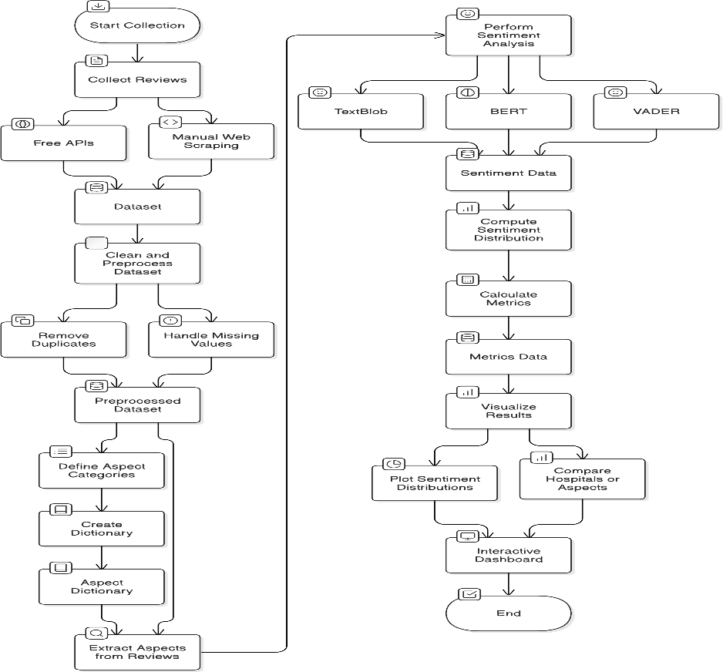

**Fig 1 : Block Diagram**

# RESULT AND DISCUSSION

## Overall Sentiment Distribution

The analysis revealed significant insights into the sentiment trends across multiple aspects related to hospital reviews. Sentiment analysis was conducted using three distinct models: TextBlob, VADER, and BERT. Each model provided a unique perspective on the sentiment polarity of the reviews, ensuring a comprehensive understanding of user feedback.

Across all aspects, BERT demonstrated a tendency to classify sentiments with more granularity, particularly in detecting nuanced positive and negative emotions. TextBlob, which relies on lexicon-based polarity, leaned towards neutral sentiments in ambiguous cases, while VADER offered a middle ground, capturing intensity in both positive and negative classifications.

## Key Findings:

1. **Positive Sentiments**: Most reviews showcased a predominance of positive sentiments, particularly in aspects related to *staff* and *facilities*. This highlights a general satisfaction in these domains.
2. **Negative Sentiments**: Aspects like *cost* and *wait time* displayed a notable share of negative sentiments, pointing towards areas requiring improvement.
3. **Neutral Sentiments**: Neutral sentiments were frequently observed in aspects such as *communication* and *cleanliness*, indicating mixed feedback or areas where reviews lacked strong emotional tones.

## Visualization:

Sentiment Distribution Plots: Comparative bar charts for TextBlob, VADER, and BERT sentiments across all aspects.

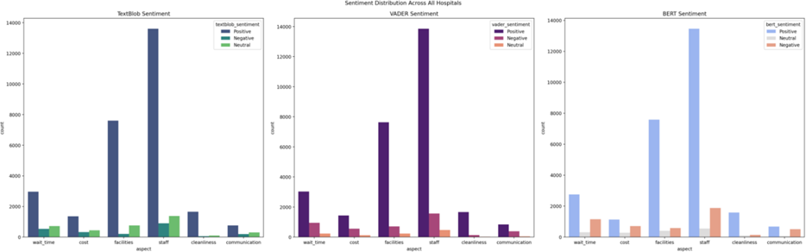

## Aspect-Specific Analysis

**Fig 2: Sentiments across all aspects**

A detailed exploration of sentiment trends by aspect provided further insights:

## Facilities

* + **Positive Sentiment**: Highlighted state-of-the-art infrastructure and well-maintained amenities.
  + **Negative Sentiment**: Issues were primarily centered on insufficient parking space and limited accessibility features.

## Staff

* + **Positive Sentiment**: Praise for friendly and professional behavior was widespread.
  + **Negative Sentiment**: Complaints arose concerning unavailability during peak hours.

## Cost

* + **Negative Sentiment**: Predominant grievances about high charges and billing discrepancies were recorded, signaling a need for pricing transparency.
  + **Positive Sentiment**: Some reviews appreciated affordable packages and insurance coverage in select facilities.

## Visualization:

Aspect Comparisons: Bar plots highlighting sentiment distribution, mention counts, and average scores by hospital for a selected aspect.

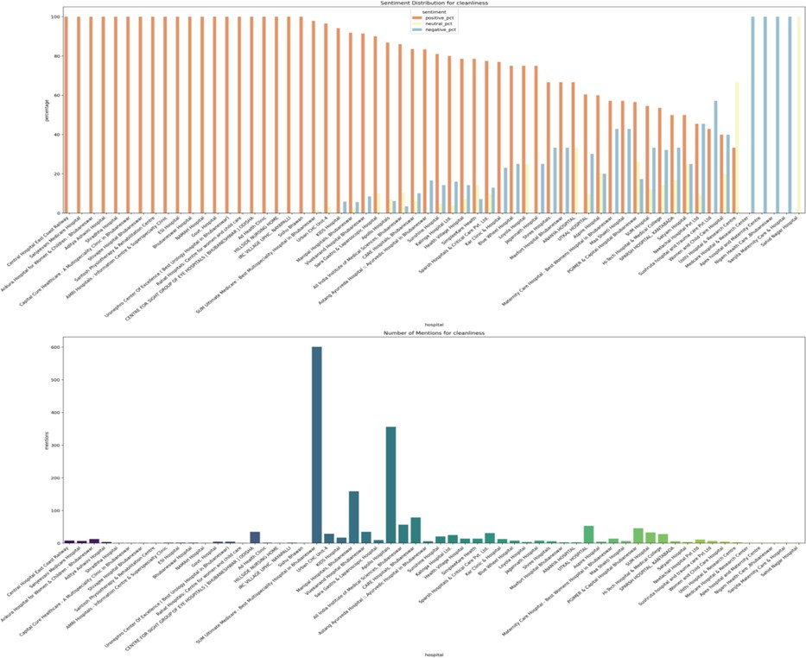

**Fig 3: Average scores by hospital for a selected aspect**

## Hospital-Specific Sentiment Analysis

A hospital-wise breakdown of sentiments revealed significant variability in service quality and user satisfaction. Key observations included:

## Hospital A:

* + Excelled in *staff* and *cleanliness* but received negative feedback on *wait time*.

## Hospital B:

* + Garnered strong positive sentiments for *facilities* and *communication* but was criticized for *cost*.

## Hospital C:

* + A balanced distribution of sentiments across all aspects, indicating overall consistency.

## Visualization:

Hospital-Specific Sentiment Analysis: Focused visualizations for individual hospitals. These visualizations are created using Matplotlib and Seaborn and rendered interactively via Streamlit.

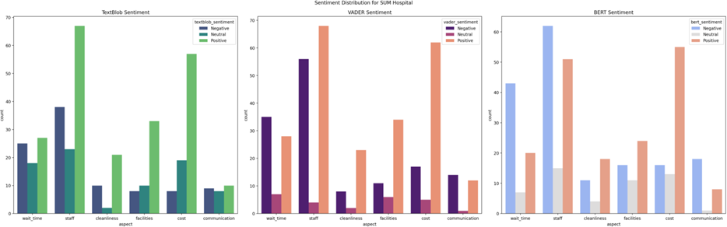

**Fig 4 : Focused visualizations for individual hospitals**

|  |  |  |  |
| --- | --- | --- | --- |
| **Title** | **Hospital Rating** | **Review Stars** | **Aspect Scores** |
| Vivekanand Hospital Bhubaneswa  r | 4.6 | 5 | {'service': 0.12956, 'cleanliness': 0.19434, 'food': 0.06478,  'facilities': 0.12956, 'staff': 0.12956} |
| Vivekanand Hospital Bhubaneswa  r | 4.6 | 3 | {'service': -0.19454000000000002, 'cleanliness': -0.29181, 'food': -0.09727000000000001, 'facilities': - 0.19454000000000002, 'staff': -0.19454000000000002} |
| Vivekanand Hospital Bhubaneswa  r | 4.6 | 1 | {'service': -0.1756, 'cleanliness': -0.26339999999999997,  'food': -0.0878, 'facilities': -0.1756, 'staff': -0.1756} |
| Vivekanand Hospital Bhubaneswa  r | 4.6 | 5 | {'service': 0.19424, 'cleanliness': 0.29135999999999995,  'food': 0.09712, 'facilities': 0.19424, 'staff': 0.19424} |

|  |  |  |  |
| --- | --- | --- | --- |
| Vivekanand Hospital Bhubaneswa  r | 4.6 | 1 | {'service': -0.17516, 'cleanliness': -0.26274, 'food': -  0.08758, 'facilities': -0.17516, 'staff': -0.17516} |
| Vivekanand Hospital Bhubaneswa  r | 4.6 | 5 | {'service': 0.17624, 'cleanliness': 0.26436, 'food': 0.08812,  'facilities': 0.17624, 'staff': 0.17624} |
| Vivekanand Hospital Bhubaneswa  r | 4.6 | 5 | {'service': 0.08808, 'cleanliness': 0.13212, 'food': 0.04404,  'facilities': 0.08808, 'staff': 0.08808} |
| Vivekanand Hospital Bhubaneswa  r | 4.6 | 5 | {'service': 0.1777, 'cleanliness': 0.26654999999999995,  'food': 0.08885, 'facilities': 0.1777, 'staff': 0.1777} |
| Vivekanand Hospital  Bhubaneswa r | 4.6 | 4 | {'service': 0.16040000000000001, 'cleanliness': 0.2406,  'food': 0.08020000000000001, 'facilities':  0.16040000000000001, 'staff': 0.16040000000000001} |
| Vivekanand Hospital Bhubaneswa  r | 4.6 | 5 | {'service': 0.13816, 'cleanliness': 0.20723999999999998,  'food': 0.06908, 'facilities': 0.13816, 'staff': 0.13816} |

## Discussion

**Table 2: Scores for hospitals based on aspects**

The analysis demonstrates the utility of combining multiple sentiment analysis models to achieve robust and reliable sentiment classification. The results indicate key strengths and weaknesses for hospitals, enabling targeted improvements.

## Implications:

* + Hospitals can leverage these insights to address specific pain points, such as reducing *wait times* or ensuring cost transparency.
  + Positive trends in aspects like *staff* and *facilities* can be maintained and further strengthened to enhance overall user satisfaction.

## Limitations:

* + The analysis is reliant on the quality and diversity of review data. Certain aspects may have limited representation, potentially skewing results.
  + While BERT offers deep insights, its computational cost and complexity pose challenges for real-time applications.

Future research could incorporate advanced NLP techniques or extend the analysis to include reviews from other regions, ensuring broader generalizability of results.

# CONCLUSION

In an era where patient-centric care is paramount, the importance of accessible, transparent, and detailed hospital review systems cannot be overstated. Traditional star-based rating systems, while simple to understand, fail to meet the nuanced needs of patients seeking healthcare services tailored to their specific priorities. These aggregate scores obscure the complexities of patient experiences, leaving critical aspects such as cleanliness, staff behavior, facilities, and cost unexplored. This shortcoming not only impedes patients from making informed decisions but also deprives hospitals of actionable feedback necessary for targeted improvements.

Our study introduces a transformative framework for aspect-based sentiment analysis, addressing the limitations of traditional review systems by providing granular insights into patient feedback. By categorizing hospital reviews into distinct aspects, our system empowers users to evaluate and rank hospitals based on the criteria that matter most to them. Whether a patient prioritizes the efficiency of staff, the quality of food, or the level of cleanliness, this framework facilitates personalized decision-making that aligns with individual needs and preferences.

The inclusion of three distinct sentiment analysis models—TextBlob, VADER, and BERT— ensures the robustness and reliability of the sentiment evaluation process. TextBlob’s lexicon- based simplicity offers a baseline for sentiment analysis but may falter with complex linguistic nuances. VADER bridges this gap by effectively handling sentiment intensity, negations, and informal language, making it particularly suitable for short, expressive reviews. BERT, the most advanced of the three, leverages deep learning to uncover contextual relationships, enabling it to capture subtle sentiments in detailed reviews with remarkable accuracy. By comparing these models, we not only validate the reliability of our findings but also provide insights into the strengths and weaknesses of each approach, creating a comprehensive sentiment analysis toolkit.

Our results underscore the value of aspect-based sentiment analysis in enhancing healthcare transparency and empowering patients. Visualizations, such as sentiment distributions and aspect-specific comparisons, are presented through intuitive dashboards, allowing users to engage with the data interactively. These tools enable patients to identify hospitals excelling in areas they value while simultaneously providing hospitals with the feedback necessary to address shortcomings. For example, a hospital receiving consistently low scores in cleanliness can use these insights to implement targeted interventions, ultimately improving patient satisfaction and outcomes.

Moreover, our analysis reveals important correlations and divergences among the sentiment models. While TextBlob and VADER align in their handling of explicit sentiments, BERT’s contextual capabilities often highlight subtleties missed by the former models. These findings suggest that integrating multiple models can provide a more holistic view of sentiment, ensuring that no critical insights are overlooked.

The implications of this study extend beyond individual patients and hospitals. Healthcare systems and policymakers can use these insights to benchmark hospital performance, identify systemic issues, and prioritize resource allocation. The granular aspect-based approach also provides a foundation for broader applications, such as assessing patient satisfaction at a regional or national level, thereby contributing to the continuous improvement of healthcare delivery.

In conclusion, this study represents a significant advancement in how patient feedback is analyzed and utilized. By transitioning from simplistic star-based ratings to a detailed, aspect- driven framework, we empower patients to make informed, personalized choices while equipping hospitals with the data-driven insights needed for improvement. The integration of TextBlob, VADER, and BERT ensures a robust and multi-faceted sentiment analysis process, while interactive visualizations enhance accessibility and engagement. Together, these innovations pave the way for a more transparent, accountable, and patient-centered healthcare system. As the healthcare landscape continues to evolve, this framework serves as a blueprint for leveraging data-driven insights to improve patient satisfaction and outcomes.